**Part 1 – Oscilloscope Configuration and Signal Movement**

1. **Q:** What does an oscilloscope measure?

**A:** An oscilloscope measures the electrical signals that occur in responses to physical stimuli through the use of a graphical display which outputs the signals.

1. **Q:** What is the function of the alligator clip connected to the oscilloscope probe? To what it should it be connected? What happens if the clip is left unconnected?

**A:** The alligator tip is used to connect the circuit the oscilloscope is measuring to the ground. It mainly should be connected to “GND” connector of the oscilloscope. If not connected, this may result in interference with signals in the circuit.

1. **Q:** Many oscilloscope probes feature a switch which allows the user to change the probe between 1X and 10X. What is the function of this slide switch? Why should we not utilize function generator cables as oscilloscope probes?

**A:** The function of the slide switch is meant to adjust the attenuation of probe to 10 different divisions of measurement. Hence, these are for measurements unlike the probes for the function generator. The cables for the function generator are to be used for powering a circuit with certain specifications from the oscilloscope such as frequency, signal type, etc.

1. **Q:** What is the minimum oscilloscope performance required to capture 2 msec of a 1V, 250 MHz sine wave?

A: $bandwidth=5*250 MHz=1250 MHz$

$sample rate=5*f_{Highest}=5*250 MHz=1.250 GS/sec$

$record length=acquired time*sample rate=2 msec*\frac{12500MS}{sec}=2.5M points$

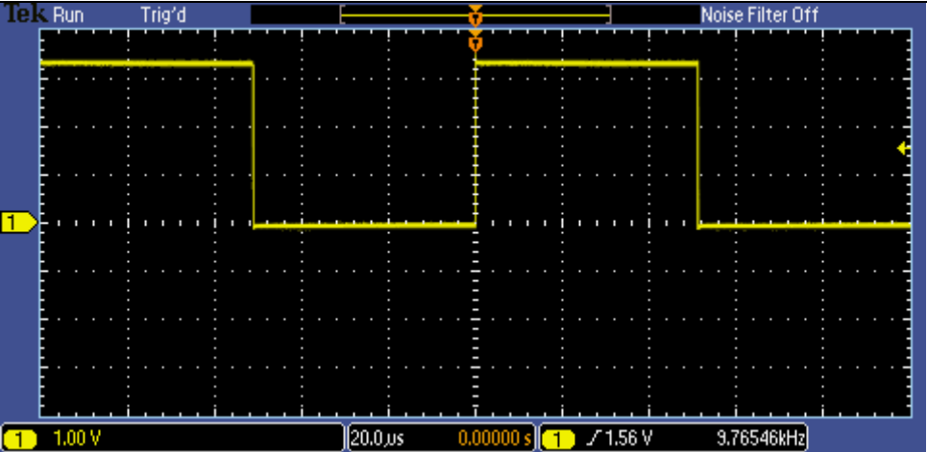

*Figure 1 – Image Taken from Lab 1 Instruction*

1. Answer the questions below based on the display shown here:
   1. **Q:** What is the peak-to-peak voltage of the signal?

**A:** The peak-to-peak voltage of the signal is about 3.4 V.

* 1. **Q:** What is the voltage of the positive peak?

**A:** The positive peak of the voltage is 3.4 V.

* 1. **Q:** What is the voltage of the negative peak?

**A:** The negative peak of the voltage is 0 V.

* 1. **Q:** What is the period and frequency of the signal?

**A:** The frequency of the signal is $9.76546kHz$. The period of the signal is .

* 1. **Q:** What does the yellow arrow contained within the red circle on the image above denote?

**A:** The yellow arrow contained within the red circle is the waveform ground level indicator of the oscilloscope.

* 1. **Q:** What does the yellow arrow contained within the green circle on the image above denote?

**A:** The yellow arrow contained within the green circle denotes the position of the trigger level the Oscilloscope is set at. This is primarily called the Trigger Voltage level.

1. **Q:** An oscilloscope’s vertical axis controls are used to control which parameter?

**A:** The vertical axis controls are used to change two different parameters of the Oscilloscope display. These two parameters are the scale and position knobs for voltage. The position knob moves the waveform up and down and is used to align the waveform to the vertical divisions while the scale knob adjusts the waveform to be higher or lower with scale self-adjusting.

1. **Q:** If the horizontal scale factor were set to 1 μsec/div, how long would the displayed waveform be?

**A:**

$time window=horizontal scale factor*10 divisions=\frac{1μsec}{div}*10 div=10μsec$.

As the work shows above, it would be 10 microseconds for displaying a waveform.

1. **Q:** With the horizontal scale factor set to 200 μsec/div and the record length set to 1 Mpoints, what is the oscilloscope’s sample rate?

**A: $time window=horizontal scale factor*10 divisions$**

$time window=\frac{200μsec}{div}*10 div=2000μsec$

$record length=acquired time*sample rate$

$\frac{record length}{acquired time}=sample rate$

$\frac{1 Mpoints}{2msec }=500 MS/s$

1. **Q:** Signal Measurements using tinkercad oscilloscope and Function Generator

**A:**

* **Peak-to-Peak Voltage** is found by the use looking at the vertical axis of the Oscilloscope and then measuring the amplitude of the signal. In this case, the total vertical axis value is 20 V. While the total voltage of the vertical axis is 20 V, it’s important to find the value of each vertical division (otherwise called the Vertical Scale Factor) which is found by $20 V÷10 divsion=2 V per division$ (Figure 2). The total peak-to-peak voltage is the difference of the negative peak and positive peak. The positive peak is 5 V while the negative peak is 0 V, therefore the total **Peak-to-Peak Voltage is 5 V**.
* **Time Period** is found by counting the number of horizontal divisions the waveform passed and then dividing the number of horizontal divisions in relation to the time. Specifically, dividing the amount of divisions to complete one cycle of the waveform. Each horizontal division is found by the total number of divisions divided by the total time in the horizontal axis otherwise called the Horizontal Scale Factor. Based upon Figure 1, This value is found by $1 divsion÷10ms=0.1ms per division$ therefore, **the time period is 1 microsecond.**
* **Frequency** is found by the division of 1 over the time/signal period. Therefore, the expression to find the value would be $\frac{1}{0.001 sec}=1000 Hertz$. Therefore, **the Frequency is 1 kHz.**

*Figure 1 – Testing with 10 milliseconds per division.*

*Figure 2 – Testing with 5 microseconds per division.*

*Figure 3 – Testing with 1 second per division.*

**Part 2 – Arbitrary Signal Measurement**

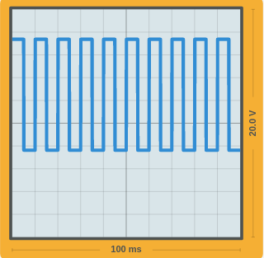

*Figure 2.1 - Image Taken from Lab 1 Instruction*

Horizontal Scale Factor: $100 ms÷10 divsions=10 ms per divsion$

Vertical Scale Factor: $20 V÷10 divsions=2 V per divsion$

Peak-to-Peak voltage: $7.1 V-\left(-2 V\right)=9.8 V$

Frequency: $\frac{1}{0.01 sec}=100 Hz$  
Period: $1 divsions*\frac{10 ms}{1 div}=10 ms$

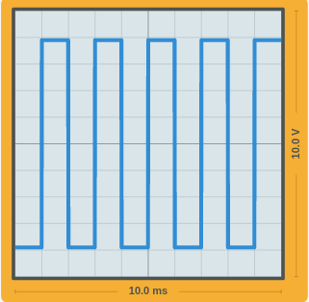

*Figure 2.2 - Image Taken from Lab 1 Instruction*

Horizontal Scale Factor: $10 ms÷10 divsions=1 ms per divsion$

Vertical Scale Factor: $10 V÷10 divsions=1 V per divsion$

Peak-to-Peak voltage: $4 V-\left(-4 V\right)=8 V$

Frequency: $\frac{1}{0.002 sec}=500 Hz$  
Period: $2 divsions*\frac{1 ms}{1 div}=2 ms$

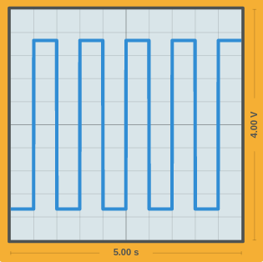

*Figure 2.3 - Image Taken from Lab 1 Instruction*

Horizontal Scale Factor: $5 s÷10 divsions=0.5 s per divsion$

Vertical Scale Factor: $4 V÷10 divsions=0.4 V per divsion$

Peak-to-Peak voltage: $1.4 V-\left(-1.96 V\right)=3.36 V$

Frequency: $\frac{1}{1 sec}=1 Hz$  
Period: $2 divsions*\frac{0.5 s}{1 div}=1 s$

**Part 3 – Lighting an LED**

1. **Q:** What is the voltage drop across the terminals of the power supply?

**A:** The voltage drop across the power supply is 5 V (as shown below).

1. **Q:** What is the voltage drop across the legs of the LED?

**A:** The voltage drop across the legs of the LED is 2 V.

1. **Q:** What is the voltage drop across the legs of the resistor?

**A:** The voltage drop across the legs of the resistor is 3 V.

1. **Q:** Do the voltage drops sum to the expected value? Explain what the expected value is.

**A:** The expected summation of the voltage drops is to be 2 V as the voltage drop from the LED removed 2 V and the resistors also removing 3 V from the circuit.

1. **Q:** Using Ohm’s law (V = IR), calculate the current flowing through the circuit.

**A: $I=\frac{5-2}{330}→\frac{3}{330}→0.00909 A$**

1. **Q:** If the power rating of an LED is 10W, and the circuit’s power supply is fixed at 5V, what size resistor would you use to result in the brightest LED without burning it out? (Remember P = VI)

**A: $10=5I→I=2$**

$V=IR→5=2R→R=2.$ 5

A 2.5 Ohm resistor is needed for the LED to be used at maximum power without burning out.

1. **Q:** What happens when you reverse the LED? Why does this happen?

**A:** The LED does not turn on reversed due to anode and cathodes being flipped. Due to these two components being flipped the electrons in the circuit cannot flow through the cathode thus not “powering” the LED. This makes the circuit act as an open circuit as LED make electricity go in only one direction.

**Part 4 – Pullups, Pulldowns, and Pushbuttons**

*Figure 1 –**Both circuit’s without button pressed.*

1. **Q:** Measure the point in both circuits labeled GPIO. For both circuits, what is the voltage at the measurement point when the button is not pressed? What is the voltage when the button is pressed?

**A**: The voltage measured between the two circuits is nearly 0 V and 5 V except these two values flip between each other when the buttons are pressed. This is due to the circuits having different low and high states when the buttons are pressed. In this case, the Pulldown circuit is in a low state by default but when pressed it goes into a high-state while the Pullup circuit operates in default high-state but goes into a low state when pressed.

1. **Q:** What is the function of the resistor? What would happen if the circuit did not include a resistor?

**A:** The function of the resistor is to keep the voltage of the circuit consistent with the source voltage otherwise if the resistor wasn’t present when the button is pressed the voltage of the circuit would drop to 5 mV which isn’t ideal in most situations.

1. **Q:** Most microcontrollers can accept digital inputs. Where would you connect a microcontroller’s digital input pin to the above circuits to read the state of the push button?

**A:** For a microcontroller to accept digital inputs, it would be ideal to connect the microcontrollers digital input pin between the resistor and pushbuttons. For a Pulldown circuit, due to being in a low-state by default, this means the flow of current would go straight through the circuit to GND thus ignoring the microcontroller digital input pin but when pressed, due to current fully going through the pushbutton, it would reroute to the digital input pin of the microcontroller thus giving input. This idea works the same as for the Pullup circuit but instead the current would flow through the digital input pin of the microcontroller instead of GND unless the pushbutton is pressed.

1. **Q:** What is the functional difference between a push button and a toggle switch? Draw both of the above circuits but substitute a toggle switch for the push button. Include the drawings in your lab report, and label where the signal from the switches should be measured.

**A:** The main functional difference between the push button and toggle switch is that while the button needs to be continually pressed to be in a “on” state the toggle switch just needs to be flipped without any other interaction to keep it in the same “on” state. Beyond that, these two inputs in their functionality of routing current works the same as the push buttons with only the toggle switch being able to retain that state without any interaction other than flipping the switch.

*Figure 2 – Toggle Switch circuits.*

**Extra Credit**

1. A screenshot of a computer

   Description automatically generated
2. A close up of a sign

   Description automatically generated